**Green Society Public School**

**D-23**

**Ratnanagar-7, Sauraha, Chitwan**

**First Terminal Examination-2082**

**Class: U.K.G Time: - 2 hrs. F.M.: 50**

**Sub: English P.M.: 18**

|  |
| --- |
| **Name: Roll No.: Sec.:** |
| **­­­­­­­­­­­­ ________________ ______________ OBT.MARKS:**  **INVIGILATOR EXAMINER** |

1. **Circle the consonant letters only. (3)**

b i k

a f c

o g h

1. **Write down vowel letters. (5)**

1. **Make 2/2 words. (5)**

B

C

F

O

N _____

1. **Make 'at' words. (5)**

_______________________________

______________________________

______________________________ ______________________________

______________________________

1. **Put ‘a’ or ‘an’ before word. (5)**

a. ink

c. pan

e. rose

b. eye

d. ant

1. **Circle the non -rhyming word. (5)**

Pit Kid sit fit

Box mom pox fox

Pud bud cud bus

ted led fed yes

peg beg hem keg

1. Make sentences using ‘This’ and ‘That’. (5)
2. 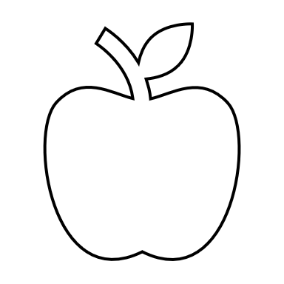_________________ is an apple.
3. _________________is a banana. 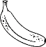
4. 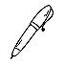 _________________is a pen.
5. _________________is a book. 
6. _________________is a butterfly.
7. 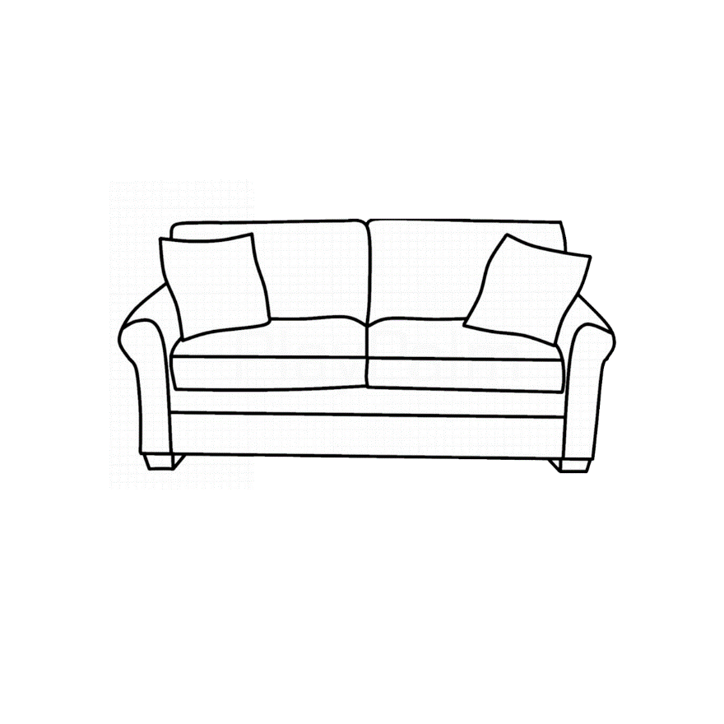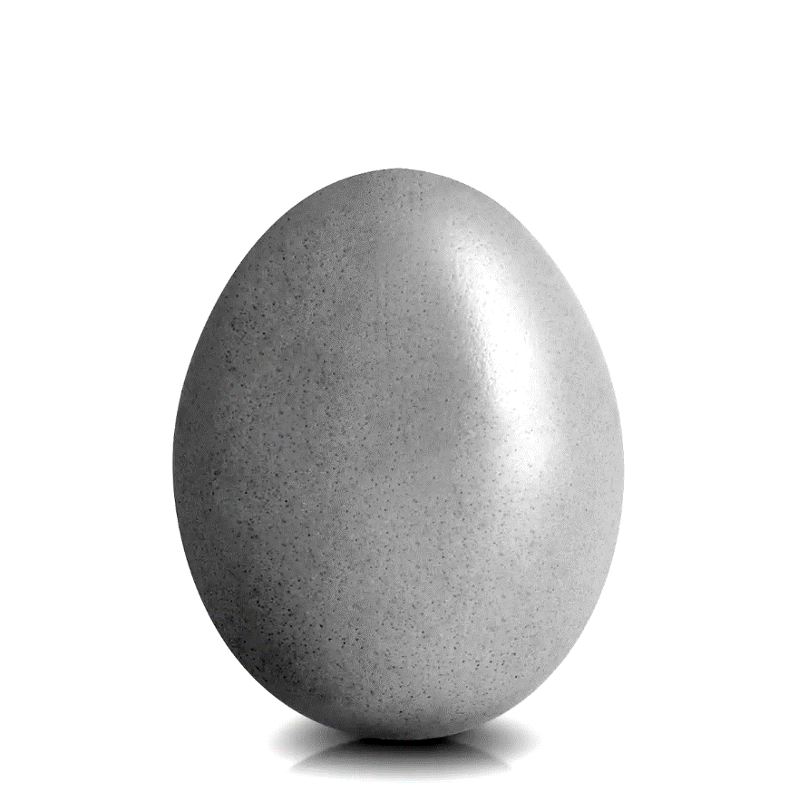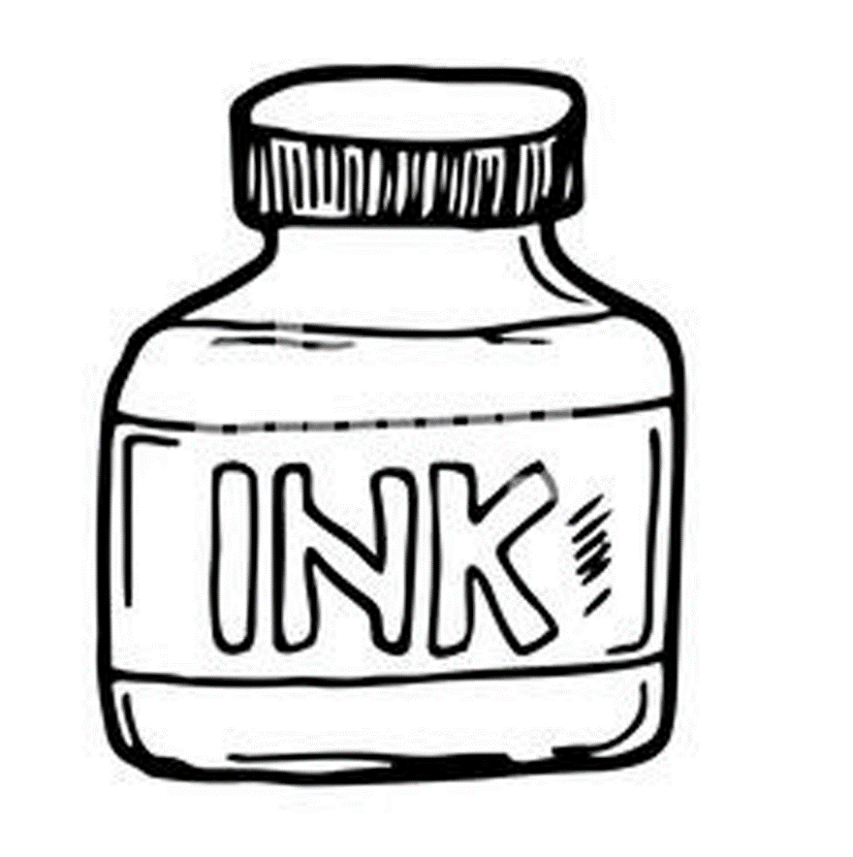**Write the name of given picture. (5)**

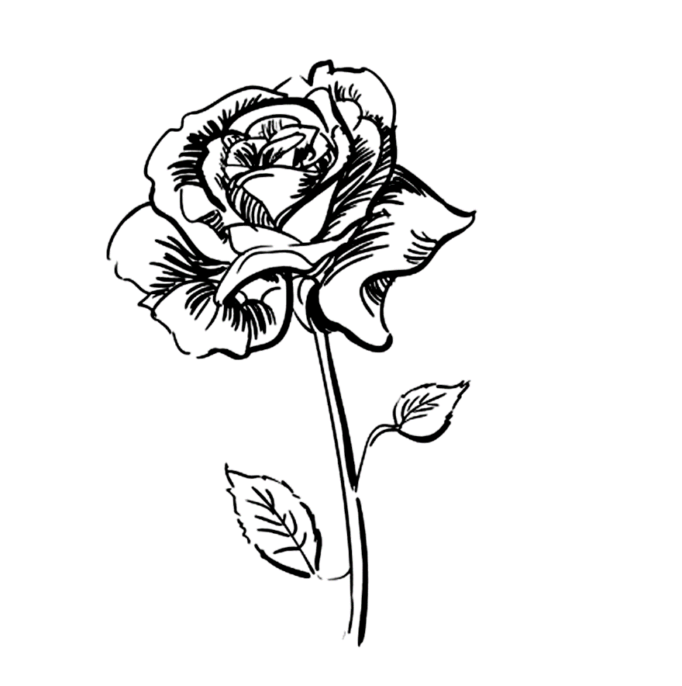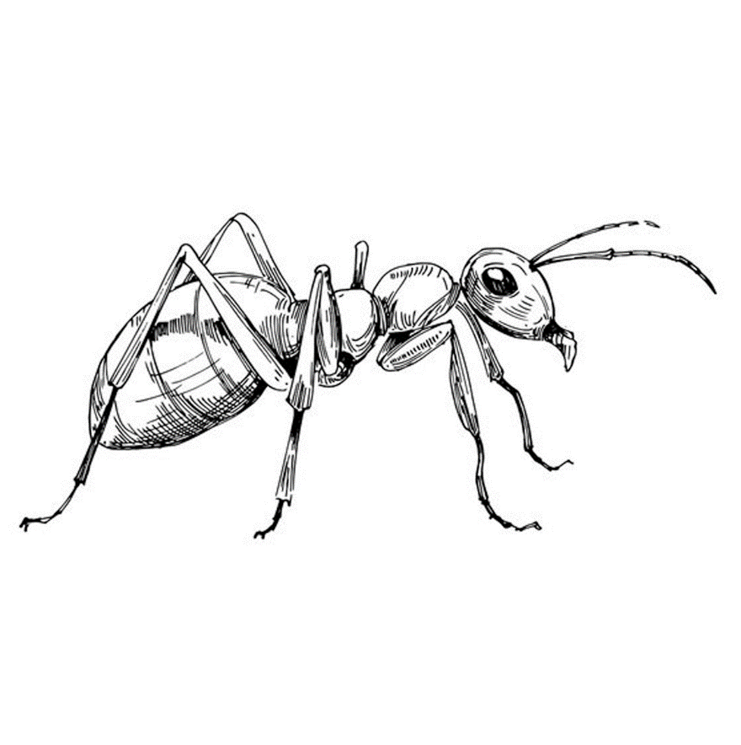



1. **Fill in the missing letters. (6)**
2. **e**______**e b. l**______**g c. h**______**a**______

**d. n**______**s**______ **e. e**______**r f. l**______**p**______

1. **Make sentences with the given table. (6)**